Jack Melcher

67574625

EECS 101

1/29/2017

HW 3

Written Problem

8 8 14 10 11

12 9 12 10 10

12 10 12 12 8

14 11 8 9 11

Region 1

8 8 10

9 10 10

10 8

8 9

Step Process for Region 1

Step 1

N = 1: 8

$μ=\frac{8}{1}=8$

$σ_{1}^{2}=0$

$H\left(R_{1}\right)=TRUE$

Step 2

N = 2: 8, 8,

$μ=\frac{16}{2}=8$

$σ_{1}^{2}=0$

$H\left(R_{1}\right)=TRUE$

Step 3

N = 3: 8, 8, 9

$μ=\frac{25}{3}=8.33$

$σ_{1}^{2}=\frac{2}{9}=0.22$

$H\left(R_{1}\right)=TRUE$

Step 4

N = 4: 8, 8, 9, 10

$μ=\frac{35}{4}=8.75$

$σ_{1}^{2}=\frac{11}{16}=0.6875$

$H\left(R_{1}\right)=TRUE$

Step 5

N = 5: 8, 8, 9, 10, 8

$μ=\frac{43}{5}=8.6$

$σ_{1}^{2}=\frac{16}{25}=0.64$

$H\left(R_{1}\right)=TRUE$

Step 6

N = 6: 8, 8, 9, 10, 8, 9

$μ=\frac{52}{6}=8.67$

$σ_{1}^{2}=\frac{5}{9}=0.55$

$H\left(R_{1}\right)=TRUE$

Step 7

N = 7: 8, 8, 9, 10, 8, 9, 8

$μ=\frac{60}{7}=8.57$

$σ_{1}^{2}=\frac{26}{49}=0.53$

$H\left(R_{1}\right)=TRUE$

Step 8

N = 8: 8, 8, 9, 10, 8, 9, 8, 10

$μ=\frac{70}{8}=8.75$

$σ_{1}^{2}=\frac{11}{16}=0.6875$

$H\left(R_{1}\right)=TRUE$

Step 9

N = 9: 8, 8, 9, 10, 8, 9, 8, 10, 10,

$μ=\frac{80}{9}=8.88$

$σ_{1}^{2}=\frac{62}{81}=0.76$

$H\left(R_{1}\right)=TRUE$

Step 10

N = 10: 8, 8, 9, 10, 8, 9, 8, 10, 10, 10

$μ=\frac{90}{10}=9$

$σ_{1}^{2}=\frac{4}{5}=0.80$

$H\left(R_{1}\right)=TRUE$

Step 11

N = 11: 8, 8, 9, 10, 8, 9, 8, 10, 10, 10, 11

$μ=\frac{101}{11}=9.18$

$σ_{1}^{2}=\frac{128}{121}=1.05$

$H\left(R_{1}\right)=FALSE$

Computer Problem



Figure 1: image1.ras

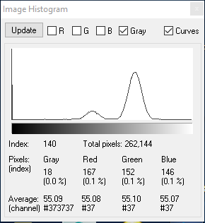

Figure 2: image1.ras histogram

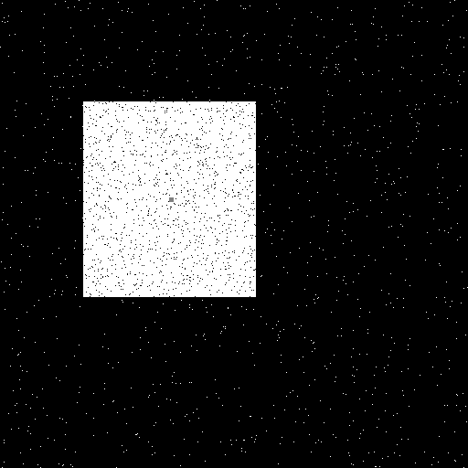

Figure 3: image1.ras binary image with object center

Threshold: 167

Area: 40082

Center Coordinate: (187, 218)



Figure 4: image2.ras

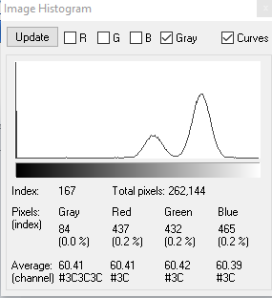

Figure 5: image2.ras histogram

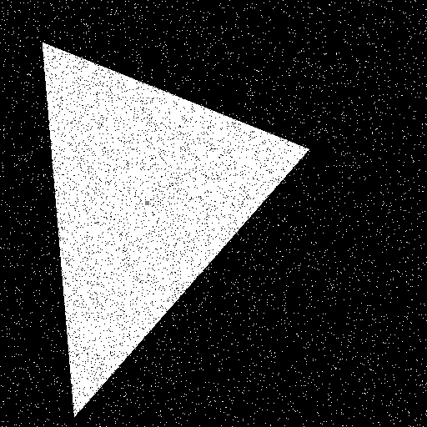

Figure 6: image2.ras binary image with object center

Threshold: 140

Area: 69668

Center Coordinate: (176, 243)

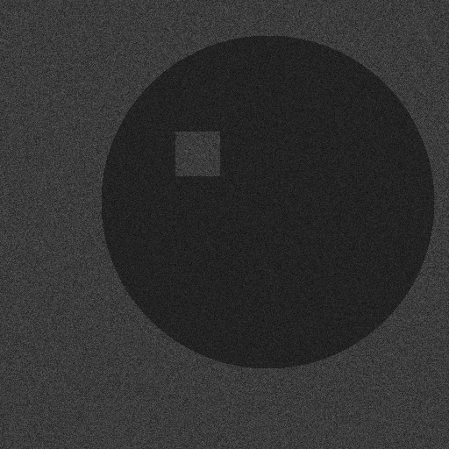

Figure 7: image3.ras

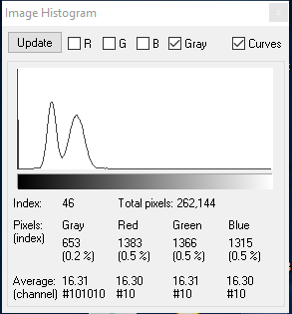

Figure 8: image3.ras histogram



Figure 9: image3.ras binary image with object center

Threshold: 46

Area: 121486

Center Coordinate: (295, 236)

